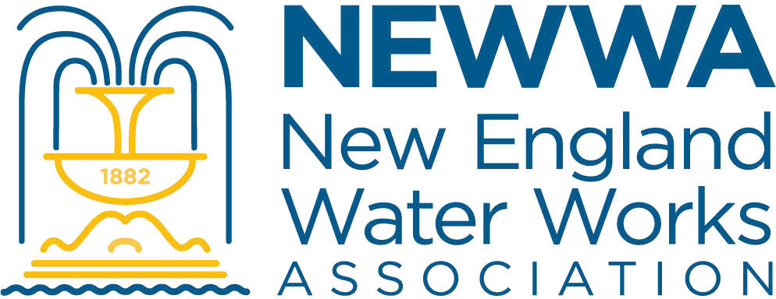

GUIDELINES FOR THE PEER REVIEW OPTION OF THE PAPERS APPEARING IN THE

***JOURNAL OF THE NEW ENGLAND WATER WORKS ASSOCIATION***

The New England Water Works Association is pleased to announce that beginning in 2003, the *Journal of the New England Water Works Association* will be providing an option to authors to have their papers undergo a peer-review process. The process will be equivalent to that used by other national and international journals in the drinking water field and will provide the additional rigor and credibility required for publication credit by many academic and research institutions. It will also provide an opportunity for constructive input and commentary for any other authors desiring it for their papers. Papers accepted through this peer-review process will be credited on their title page in the *Journal*. We are pleased to offer this additional service, because we believe that it will encourage and enable the historically fine research being conducted in the New England region to be published more frequently in a venue that will assure the maximum visibility to the regional drinking water community. Reviewers for this process will be drawn from national and international experts to assure the best input and credibility to the authors.

Papers for which authors do not desire the peer-review option, and papers that are not recommended for peer- review certification, will still be published in *Journal NEWWA* as before. Therefore, we hope that this process will stimulate the submission of more papers and the additional sharing of information that will be of value to all.

# Special Peer-Review Editorial Procedures

Authors desiring manuscript evaluation under the peer-review system should send the manuscript directly to the Assistant Editor (address below). In the cover letter the author(s) should indicate if they wish the paper to be reviewed preserving anonymity. In that case, the authorship information should be included in the submission cover letter, and obvious revealing acknowledgments should be removed until acceptance.

Reviews will be obtained from a minimum of 3 national or international expert reviewers from disciplines relevant to the content of the manuscript. In case of widely divergent or conflicting reviews, the Assistant Editor shall add supplemental reviewers as needed to resolve the conflicts and provide a consensus to the author(s). The *Journal NEWWA* will strive to return results of the peer-review to the senior author within 60 days of paper receipt by the Assistant Editor. The recommendation can be: acceptance as-is; acceptance with minor revision needed; tentative acceptance with major revision needed (may require re-review); rejection with major revision and resubmission encouraged; and rejection as a peer-reviewed paper. The author(s) will have the option of making modifications consistent with recommendations and evaluations of the reviewers and being published with the designation of passing the peer-review process. However, *should the author(s) choose not to make sufficient modifications to pass the peer-review process for any reasons, they may inform the Assistant Editor that they wish the paper to be published as-is, without the peer-review qualification.*

Following acceptance of the manuscript, the final document should be prepared and submitted in accordance with the requirements given in “Guidelines for the Preparation of Papers for Publication in the *Journal of the New England Water Works Association*.”

# Special Guidance for Submittal of Papers for the Peer-Review Option

The paper should be submitted electronically to James Malley, Assistant Editor, *Journal NEWWA* at [jim.malley@unh.edu.](mailto:jim.malley@unh.edu.)